ECA5701-NANOELECTRONICS
Saambavi U
192512099
CO1
EXPERIMENT 1
Exp. 1. Simulation of scattering and absorption of Multi-layer Sphere and CoreShell Nanoparticle using Mie-Plot tool.

Case Study 1: Scattering and absorption spectra for a single-layer sphere (core only).
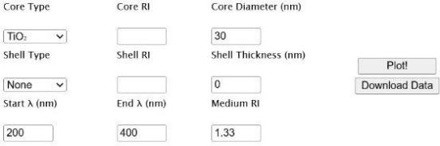
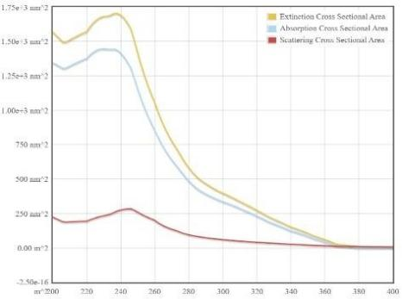

Case Study 2: Simulate the optical response of a gold (Au) nanoparticle of 50 nm diameter in water medium.
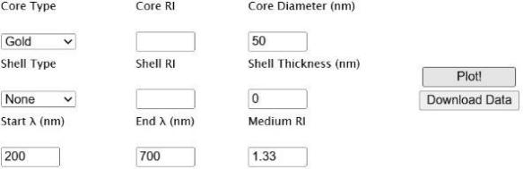
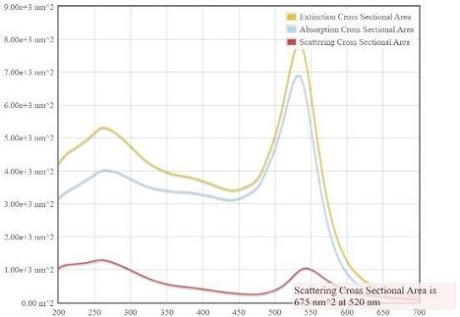
Case Study 3: Simulate a core–shell nanoparticle with a gold core (30 nm) and silica shell (10 nm).

